2021 Convergences occupied Palestinian territory Forum
Call for contributions
Deadline : May 15th
- Presentation of the 2021 Convergences occupied Palestinian territory Forum
About ACTED mission in occupied Palestinian territory
ACTED is an independent, French not-for-profit international NGO which aims to foster inclusive, low-carbon growth, improve individual skills and increase access to essential services for all, and accelerate access to societal and technological innovation for the most vulnerable. ACTED develops and implements programmes that target the most vulnerable amongst populations that have suffered from conflict, natural disaster, or socio-economic hardship. ACTED’s approach looks also beyond the immediate emergency towards opportunities for longer term livelihoods reconstruction and sustainable development.
ACTED has been operating in the West Bank and the Gaza Strip respectively since 2007 and 2008 throughout its 4 operational bases located in Hebron, Ramallah, Jerusalem, and Gaza. ACTED mission in oPt provides emergency relief and implements innovative capacity-building projects in the sectors of digital technologies and social entrepreneurship.
About Convergences
Created in 2008, Convergences is a French not-for-profit international platform for reflection, advocacy and mobilisation to build multi-stakeholder convergences between the private, public and associative sectors in order to promote the Sustainable Development Goals (SDGs) as well as the construction of a 3Zero world "Zero Exclusion, Zero Carbon, Zero Poverty".
The mission of Convergences is to stimulate constructive thinking and action, spread best practices and promote the co-construction of innovative partnerships with high societal impact in order to achieve a 3Zero world "Zero Exclusion, Zero Carbon, Zero Poverty". We are convinced that a partnership between all sectors is essential to combat poverty, exclusion and climate change. Driven by this idea, Convergences has the will to promote access for all to spaces for sharing solutions. In order to achieve this, Convergences collaborates with more than 250 partner organisations members of its Working Groups in France and internationally to co-organise its 3Zero activities.
About the 2021 Convergences occupied Palestinian territory Forum
The project’s general objective is to overcome the obstacles to development in oPt by exploiting the potential of digital tools. It will specifically be dedicated to enhance young Palestinians’ employability through the improvement of their digital perspectives. Digital innovation presents an important opportunity to overcome traditional obstacles for the most vulnerable groups, including women and people with disabilities, for whom traditional vulnerabilities can be reduced by digital tools use. ACTED and Convergences are convinced that it is by bringing together institutions, civil society, entrepreneurs, the media, academics and citizens that the impact of these initiatives will be maximised.
Therefore, the two organisations, in collaboration with a Working Group, will organise in 2021 in oPt the 1st edition of the Convergences occupied Palestinian territory Forum to develop a dialogue platform and network between all stakeholders of a sustainable and inclusive development.
The Forum shall take place in the West Bank over the course of July 2021, both in physical and digital format if the sanitary context allows it. Convergences and ACTED are committed to implementing the appropriate sanitary protocol according to the COVID-19 situation. In case of major restrictions related to the COVID-19 pandemic, the Forum will be shaped in a digital format.
- Contribute to the 2021 Convergences occupied Palestinian territory Forum
Please send your contributions to manon.vigier@convergences.org before May, 15th
You are a professional or a student network & have initiatives to share on the role and place of digital inclusion in oPt? You are inspired and the 3Zero ambition? Do you contribute to it? You can now contribute to the very first 2021 Convergences occupied Palestinian territory Forum by proposing topics, roundtables or workshops, projects or speakers! To be part of the Forum, your contribution will have to address one or more of the following issues:
Provisional title | Sustainable and inclusive growth in the Palestinian territories through digital inclusion
Thematic pillar #1 | Ensuring access to ICT: the first step towards digital inclusion
- How to provide quality digital devices everywhere and for everyone in oPt?
- Innovative and qualitative education and trainings to ensure digital literacy
- Think local, act global : local-based approach to strengthen access to ICT and digital literacy
Thematic pillar #2 | Labour market transition: a necessary evolution of the digital sector?
- From a degree to a job: bridging the gap between labour market requirements and academic curriculums propositions
- How to fight gender based discrimination in digital sector?
- In a pool rich of its digital entrepreneurs, ensuring the match of offer and demand
Thematic pillar #3 | Digital innovation: levelling up the impact of organisations
- Digital for development: what is at stake for your organisation?
- Tech4Good: digital to create social and environmental positive impact
- Multi-actor partnerships: all sectors coming together for the achievement of the SDGs in oPt

ACTED and Convergences will study all proposals received and inform you on the next steps regarding your contribution. If your proposition is selected, we will let you know how your contribution can be integrated into the programming, or will offer you to co-organise a conference or workshop.

*** Please read the recommendations below carefully before completing the form ***
In order to submit your contribution, please complete the contribution form as follows:
- Fill in the table relating to the general information concerning your organisation;
- Fill in the contribution form as follow:
- Choose one of the topics proposed in the “Pillar” column;
- By applying a horizontal reading, chose one of the themes proposed in the “Themes” column;
- Fill in the “issues” column: in your opinion, what are the issues to be addressed on this subject? What are the objectives to be achieved?
- Fill in the column “Projects and examples”: do you know of any innovative projects to be promoted on this subject, any material to use?
- Fill in the “Speakers” column: do you have any suggestions for speakers or structures to invite to share their expertise on this subject?

Information to know before filling out the form:
- A session usually lasts 90 minutes;
- Speakers in a session must represent the different sectors (public, private, solidarity, academic, media);
- Gender balance must be observed when setting up the speakers for a session;
- The proposed session must be interactive and allow dialogue with the audience;
- The session should highlight concrete initiatives and encourage multi-stakeholder partnerships;
- The proposed session must be related to the themes presented in the table;
- You can propose several contributions! Complete one table per proposal.

- Your contribution to the 2021 Convergences occupied Palestinian territory Forum
In order to contribute to the programming of the 2021 Convergences occupied Palestinian territory Forum, we invite you to fill in the form below and return it to manon.vigier@convergences.org before May, 15th
- General information
Organisation
Name
Website
Telephone number
Type of structure | ☐ Public or international organization  ☐ Company or Corporate Foundation  ☐ Solidarity actor  ☐ Academic organisation  ☐ Media
Brief description of activities related to sustainable development and SSE
- I would like to join the Working Groups of the 2021 Convergences oPt Forum
- Contribution Form
Pillar | SDGs addressed in your contribution
☐ Thematic Pillar #1  Ensuring access to ICT: the first step towards digital inclusion  ☐ Thematic pillar #2  Labour market transition: a necessary evolution of the digital sector?  ☐ Thematic pillar #3  Digital innovation: levelling up the impact of organisations | 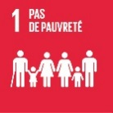  ☐ | 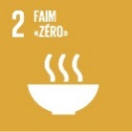  ☐ | 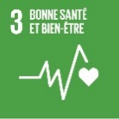  ☐
 | 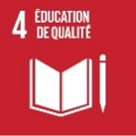  ☐ | 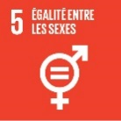  ☐ | 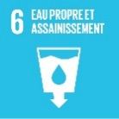  ☐
 | 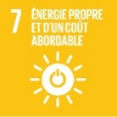  ☐ | 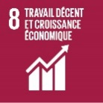  ☐ | 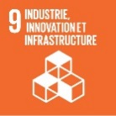  ☐
 | 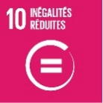  ☐ | 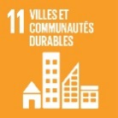  ☐ | 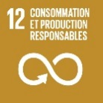  ☐
 | 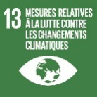  ☐ | 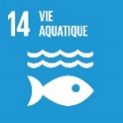  ☐ | 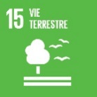  ☐
 | 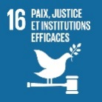  ☐ | 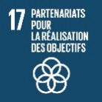  ☐
Session title
Key issues and stakes formulated in short sentences | 1.  2.  3.
Projects / Examples
Speakers  Requirements  - Must be at least one person from your organisation  - Respect of gender equity | 1.  2.  3.  4.  Moderation :

